CREATE AND CONFIGURE IBM CLOUD SERVICES

|  |  |
| --- | --- |
| **Team ID** | PNT2022TMID23841 |
| **Project Name** | IoT based Safety Gadget for Child Safety, monitoring and notification |

|  |  |
| --- | --- |
| **TEAM LEADER &TEAM MEMBERS** | 1. DHARANI N  2.ADITHYA V  3.DEEPIKA B  4.GOPIKA M |

CREATE NODE-RED SERVICE

STEP 1:

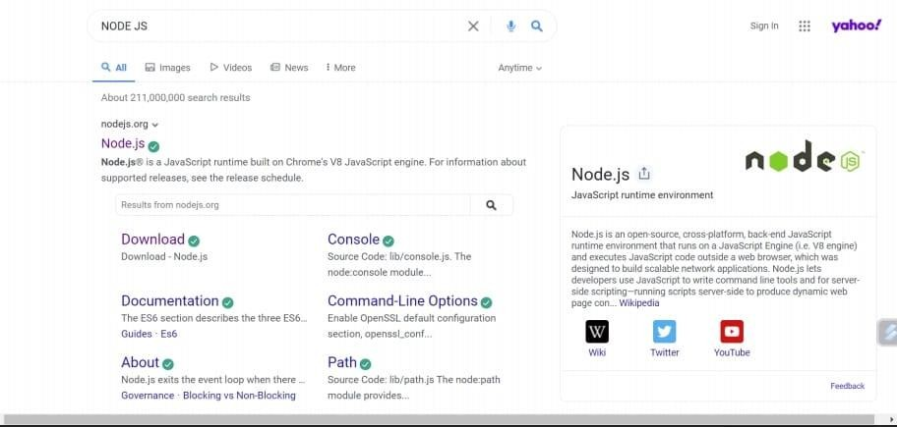

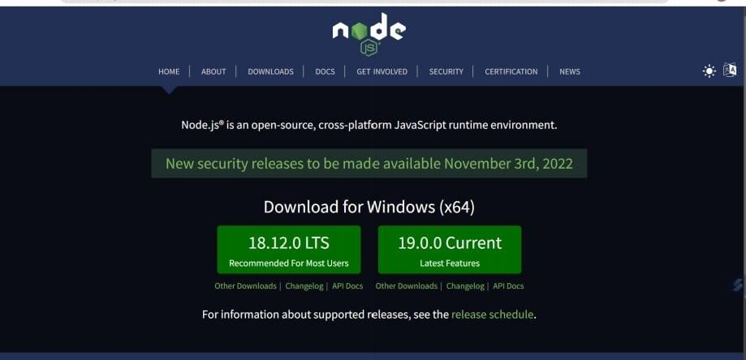STEP 2

:

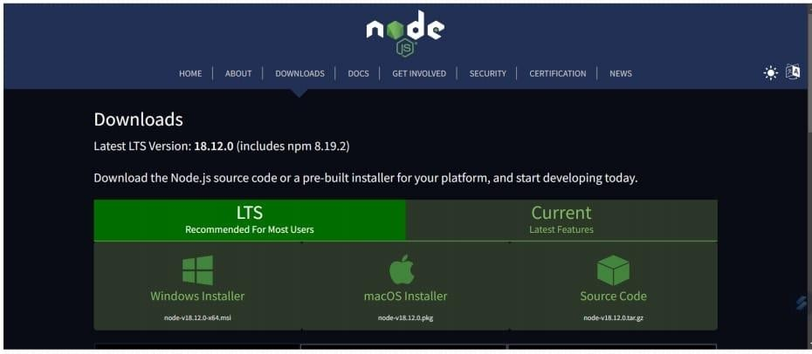STEP 3:

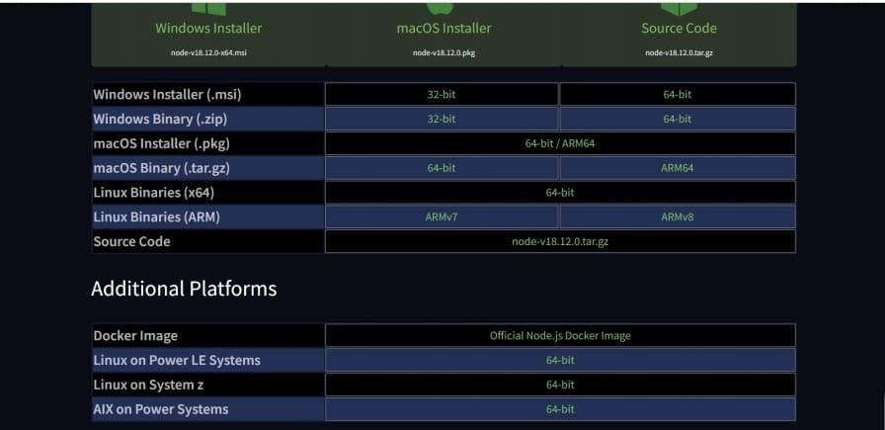STEP 4:

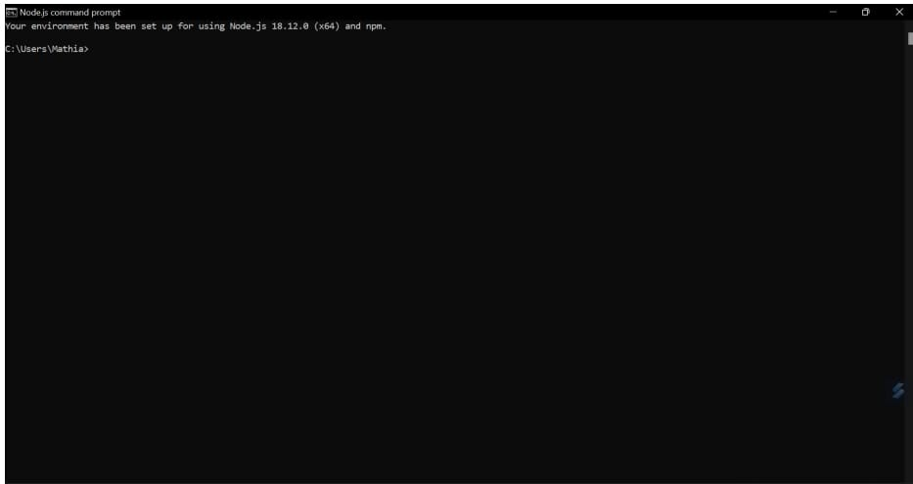STEP 5:

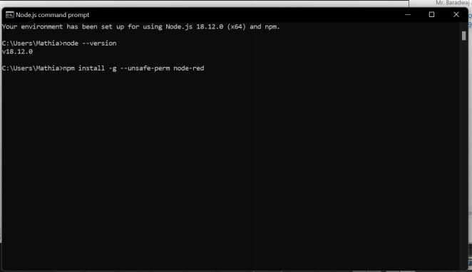STEP 6:

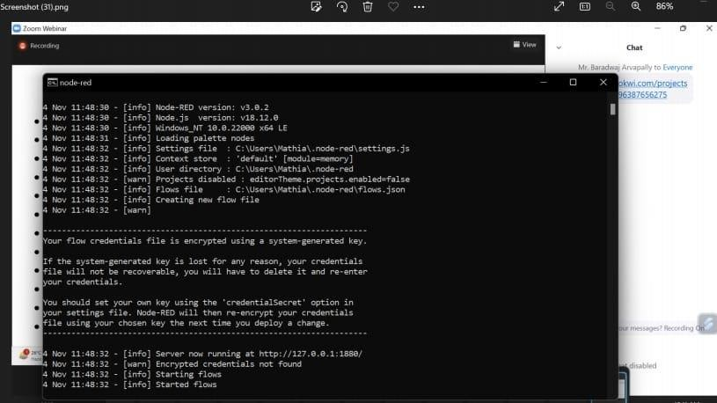STEP 7:

STEP 8:

http://127.0.0.1:1880/

STEP 9:

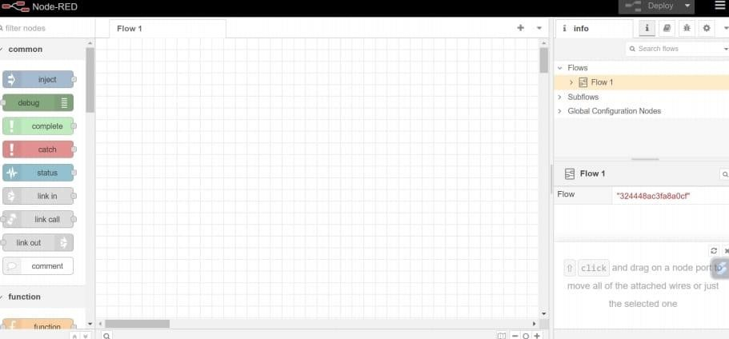

STEP 10:

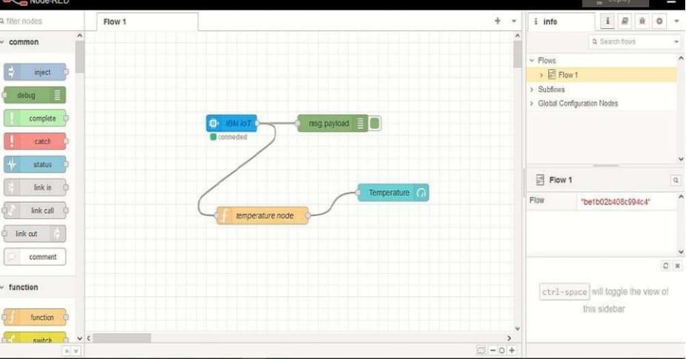

RESULT:

Thus,Node-red service was created.